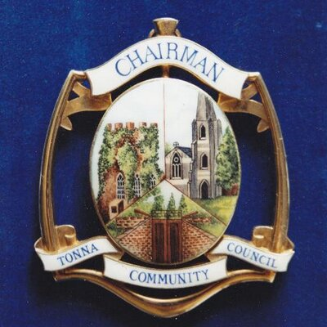

**Tonna Community Council Members for 2022-2023**

**Chair for 2022/23**

Councillor Bill Walters

**Vice Chair for 2022/23**

Councillor Darren Harrison

**Members for 2022/23**

Councillor Ms Johanne Barnes

Councillor Huw Bradley

C.B. Councillor Mrs Leanne Jones

Councillor Martyn Lyddon

Councillor Colin Powell

Councillor Simon Radford

Councillor Stephen Roberts

Councillor Mike Rowlands

Councillor Paul Sambrook

**Clerk / RFO**

Peter L. White - 32, Heol Caredig, Tonna, Neath, SA11 3LQ

Tel: 01639 644886 Tel: 07737 853295