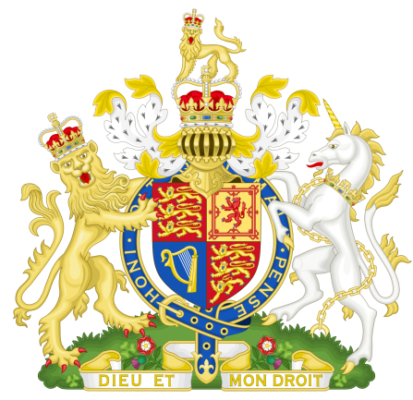

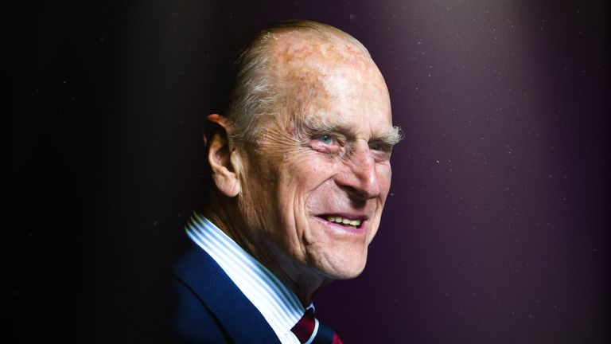

**His Royal Highness passed away peacefully this morning at Windsor Castle**

**9th April 2021.**

**The Royal family join people around the world mourning his loss.**

**As a Community Council we would like to join the rest of the Nation in acknowledging the sad passing of HRH Prince Phillip, The Duke of Edinburgh.**

**The sympathies of Tonna Community Council are with the Royal family at this time.**